Clapham and Stockwell Faith Forum invite you to a very special event, a gathering for people of all faiths and none, a celebration of the great art of story
with Indian artist and writer
Jyoti Sahi

Dialogue with a Living Presence Through Art

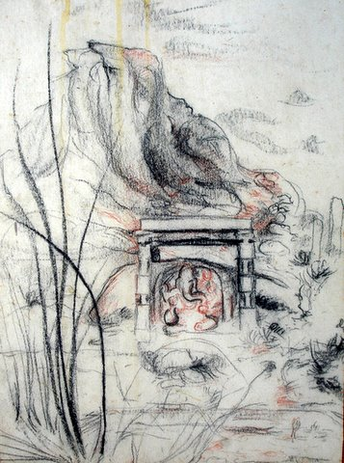

Saturday 26th April 2008: 10am to 5pm including lunch:
A day workshop exploring the place of art, story and silence in creating interfaith understanding and self-discovery. Jyoti is an artist of Christian/Hindu origin who travels throughout the world sharing his inspired insights into the place of art, nature, mysticism and meditation in different faith traditions.

Sunday 27th April 2008: 2pm to 5pm
A time for further exploration, either for those who come on Saturday and wish to discover more, or for those who can only make half a day. All welcome!

St Peters Centre for Meditation and Peace,
308 Kennington Lane, London SE11 5HY

Transport: 2 minutes walk from Vauxhall Tube and Bus Stations
Booking essential: Call Rebecca on 07958 353 652 or email info@csff.co.uk

This is a free event, funded by friends and partners of Clapham and Stockwell Faith Forum. Donations towards lunch and the continuing work of St Peters Centre will be welcomed.

