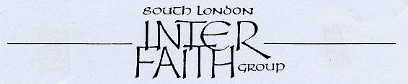
Nearly 35 years committed to greater understanding among people of faith

www.southlondonintefaith.org.uk

Annual General Meeting 2015
with a bring-and-share vegetarian meal
This event is open to all: do invite your friends to come with you.

Sunday 7th June at 4pm

Brixton Hill Methodist Church
Corner Elm Park & Brixton Hill
(entrance from Elm Park)
London SW2 2TX

On Bus Routes: 45, 59, 109, 118, 133, 159, 250, 333
get down at Jebb Avenue/Brixton Prison bus stop

10 minutes by bus from Brixton tube station or Streatham Hill railway station

Programme

4pm Arrivals

4.15pm Business Meeting
Annual Report and Financial Statement for 2014
Future arrangements
Election of Secretary, Treasurer and Committee for 2015/16
Any other business

5.30pm Meal
please bring vegetarian items to share

For enquiries please contact
Alan Gadd at 07889 221 847 or membership@southlondoninterfaith.org.uk

